Student’s name: _____________________
Class: 6/ ___
REVISION MIDTEST
I. PRONUNCIATION
A. Choose the word whose underlined part is pronounced differently.
1. A. chip B. fish C. sweet D. drink
2. A. started B. learned C. played D. scored
3 A. decided B. wanted C. needed D. watched
4. A. listened B. studied C. helped D. cleaned
5. A. works B. shops C. shifts D. plays
6. A. Opened B. played C. wanted D. filled
7. A. wanted B. decided C. needed D. learned
8. A. liked B. watched C. helped D. cleaned
B. Choose the word that has a different stressed syllable from the rest.
1. A. favorite B. water C. healthy D. prefer
2. A. champion B. gymnastics C. football D. stadium
7. A. dessert B. medal C. dinner D. vitamin
8. A. football B. dangerous C. medicine D. athletics
7. A. exercise B. afternoon C. typical D. horrible
8. A. tennis B. Japan C. hockey D. medal
7. A.tennis B. player C. event D. cycling
8. A. chicken B. prefer C. salad D. menu
9. A. stations B. bags C. papers D. books
10. A. win B. nice C. king D. sit
II. Choose the word or phrase that best completes the sentences:
1. What’s your_____________ food? – I like chicken.
A. Love B. happy C. favorite D. post office
2. He loves________________ bread with eggs.
A. to eating B. eating C. ate D. Eats
3. She usually drinks some cold_________.
A. cucumber B. apple C. juice D. chicken
4. The _____________ Games take palce every four years.
A. swimming B. gymnastics C. athletics D. Olympics
5. That swimmer __________ famous when she was eighteen.
A. became B. learned C. swam D. played
6. Tom: Let’s see a movie on Sunday? - Andy: -____________ .
A. Yes, will. B. Sound great! C. Yes, you can. D. I didn’t go.
7. She was the _____________ in the skiing competition last year.
A. champion B. team C. fan D. event
8. They don’t mind _____________in the remote area.
A. live B. to live C. living D. lived
9. He looks very _____________now, so he doesn’t need to do lots of exercises.
A. fit B. unfit C. unhealthy D. tired
10. How _____________ players are there in a double tennis match?
A. any B. many C. much D. few
11. My sister _____________ home late last night.
A. come B. came C. is coming D. comes
12. She likes watching Tour de France. It’s an exciting cycling _____________.
A. race B. match C. play D. medal

13. _______, fry and egg. Then add some paper.
A. After B. First C. Before D. Second
14. My younger brother eats _________ unhealthy snacks
A. a lot of B. much C. any D. more
15. __________ in this river. It’s deep and dangerous.
A. Swim B. Don’t swim C. Swimming D. Don’t swimming
16. There ________ many fans in the football stadium last year.
A. were B. was C. is D. are
17. The _______ Games take place every four years.
A. swimming B. gymnastics C. athletics D. Olympics
18. She likes to watch Tour de France. It is an exciting cycling ________
A. Race B. match C. play D.medal
19. I haven’t got______ bread with this egg.
A. any B. many C. some D. much
20. Do you know Tour de France? – It’s a well-known _________ race.
A. athletics B. gymnastic C. cycling D. swimming
21. Real Madrid is a famous football ____________ in .
A. fan B. team C. player D. dancer
22. They don’t like sport so they _________ interested in the cycling race on TV last night.
A. was B. wasn’t C. were D. weren’t
23. There are ____________ main types of nutrients.
A. two B. seven C. our D. six
24. Sumo wrestlers have to _______ very early.
A. get up B. go to school C. have lunch D. study
III. Look at the signs and choose the best answers
1. What does this sign mean?  A. We should stop driving cars.  B. Cars must not be turned left.  C. Cars must be turned right.  D. Cars must be parked here. | 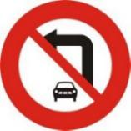 | 2. What does this sign mean?  A. You cannot go straight.  B. You can go at the speed of 60 km/h.  C. You aren’t allowed to turn around.  D. You should be careful due to the crowd ahead. | 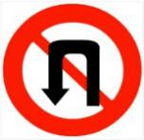
3. What does this sign mean?  A. School ahead.  B. Slippery road  C. No dog walking.  D. No animals. | 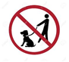 | 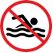  4. What does this sign mean?  A. You can swim here.  B. You are allowed to swim here.  C. You should swim here.  D. Swimming isn’t allowed here.
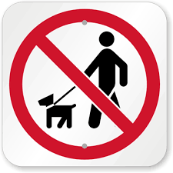  5. The sign says:  A. Dog ahead  B. No dog walking  C. No animals  D. No entry | 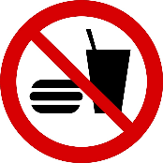  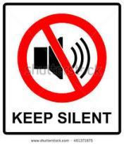  6. The sign says:  A. Bring your food and drink  B. Don’t use flashlights here.  C. You can’t bring apples here  D. No eating or drinking

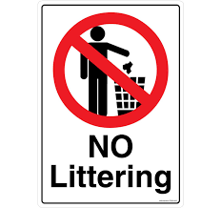  7. The sign says:  A. You can litter here.  B. You should litter here.  C. You can’t catch fish here.  D. You mustn’t litter here. | 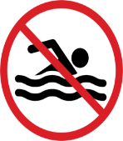  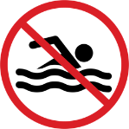  8. The sign says:  A. No talking.  B. No camping.  C. No walking.  D. No swimming.
9. The sign says:  A. You can litter here.  B. You should litter here.  C. You can’t catch fish here  D. You mustn’t litter here | 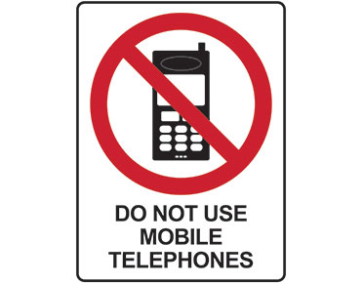  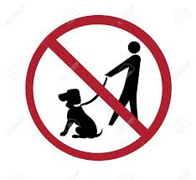  10. The sign says:  A. We can use phones here.  B. No phones are sold here.  C. Phones are not repaired here.  D. We must not use phones here.
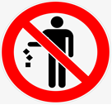  15. The sign says: _______  A. Don’t litter here.  B. Waiting area.  C. Garbage can be put here..  D. You can put garbage here. | 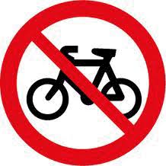  16. The sign says: _______  A. No parking  B. No talking  C. No cycling  D. No walking
III. Supply the correct form or tense of the verbs in the brackets:
1. The milk tea shop open last Monday. (be)
2. Marry in that bank in 2012. (work)
3. You shouldn’t too much unhealthy food. (eat)
4. He doesn’t mind in the country side. (live)
5. Murray first tennis matches when he was at school. (start)
6. Do you prefer a superstar? (become)
7. Look! He very fast. (run)
8. Why don’t we more fruit and vegetables? (eat)
9. Yesterday, I (go) to a restaurant with my family.
10. Robert and Stan (be) my best friend five years ago
11. You should (take) a rest when you are tired.
12. I don’t mind (do) my homework in the evening
13. In 1896, there silver medals for winners and bronze medals for second place. (be)
14. We prefer on the sofa. (sit)
15. Let’s to the movies tonight. (go)
16. Our team the match 10 days ago. ( win)
IV. Read the passage carefully, then check the statement is True or False
A. Australians love sport. They play it, they talk about it and they watch it on TV. Australian weather is perfect for sport. Young people in Australia are very active. More than 60% of children go to sports clubs. They also do activities with friends such as skateboarding, cycling, and rollerblading. The most popular sports for girls are netball, swimming, tennis, basketball, gymnastics, football, athletics, martial arts, hockey, and horse riding.
1. Australians hate sport.
2. Australian weather is good for sport.
3. More than seventy percent of children go to sport clubs.
4. The most popular sports for girls are skateboarding and badminton.
B. The first modern Olympic Games were in Greece in 1896. There were sliver medals for winners and bronze medals for second place. There weren’t any gold medals. In 1916, 1940 and 1944, there weren’t any games because of war. In 1936, twelve-year-old swimmer Inge Sorensen from Denmark was the youngest medallist in the Olympic history.
- The first modern Olympic Games weren’t in Greece.
- There were gold and silver medals for the winners.
- There weren’t any games in 1916.
- Inge Sorensen was from Ethiopia.
C. The first modern Olympic Games were in Greece in 1896. There were silver medals for winners and bronze medals for second place. There weren’t any gold medals. In 1916, 1940 and 1944, there weren’t any games because of war. In 1936, Twelve- year-old swimmer Inge Sorensen from Denmark was the youngest medallist in Olympic History.
- The first modern Olympic Games were in Argentina.
- There were gold medals in the first Olympic Games
- There weren’t any games in 1916..
- Inge Sorensen was from Denmark.
D. Minerals are important for strong teeth and bones. You can find them in meat, fish, milk, vegetables and nuts. This nutrient has got the most energy and is good for our skin and hair. The fat in food such as butter, chocolate, chips, burgers and crisps is unhealthy, but the fat in food like olive oil, nuts and some fish is healthy. Water is also a very important nutrient. You can’t live for more than one or two days without it. There’s a lot of this in fruit, vegetables and juice, too.
- Minerals are important for strong teeth and hands.
- Olive oil, nuts and some fish are healthy food.
- Water isn’t a important nutrient.
- You can’t live for more than 1 or 2 days without water.
V. Read the passage and choose the best answer:
A. Cristiano Ronaldo’s full name is Cristiano Ronaldo dos Santos Aveiro. He was born (29) ____ 5th February 1985 in Madeira, Portugal. He’s 1 meter 85 centimeters (30) ________. He’s slim and he’s got short dark hair and brown eyes. Ronaldo first (31) ______football when he was three years old, and he turned professional when he was only ten. He played for Sporting in Portugal and then Manchester United. In 2009, he moved to Real Madrid in Spain. He’s also in the Portuguese national (32)_________. Ronaldo (33)______ his first big trophy with Manchester United in 2007, when they (34)_______English Premier League champions.
29. A. On B. In C. from D. about
30. A. long B. tall C. short D. thin
31. A. plays B. playing C. played D. is playing
32. A. class B. team C. school D. City
33. A. wins B. win C. won D. Winning
34. A. is B. was C. are D. were
B. My favorite meal is breakfast. From Monday (29)_____________ Friday, I go to school early so I have a quick breakfast. I usually (30)_____________ cereal with milk or sometimes I have toast and jam, but the weekend is different! On Saturdays and Sundays, my dad (31)_____________ an English breakfast for everyone in our family. A typical English (32)_____________ is egg, bacon, sausages, tomatoes, mushrooms and baked beans (beans in tomato sauce). Then we have toast and jam. I (33)_____________ orange juice and my parents drink tea or coffee. I love breakfast on the weekend (34)_____________ I have it with my whole family.
29. A. to B. at C. between D. of
30. A. has B. having C. have D. to have
31. A. eats B. cooks C. takes D. makes
32. A. breakfast B. lunch C. dinner D. snack
33. A. eat B. go C. drink D. do
34. A. but B. because C. so D. and
C. Physical activity is the _________(29) obvious benefit of sports participation. Children spend too much watching television or __________(30) video games. But sports practices and games provide an opportunity to exercise that can help _________(31) kids in shape and healthy. Sports participation can help children develop social skills that benefit them ____________(32) their entire lives. They learn to interact not only with other children of their age, ____________(33) also with older individuals in their coaches and sports officials. Kids learn leadership skills, team-building skills and communication skills that will help them in school, their future ____________(34) and personal relationships.
29.A. more B. much C. most D. least
30. A. doing B. playing C. going D. watching
31. A. keep B. to keep C. keeping D. keeps
32. A. with B. on C. at D. throughout
33. A. and B. so C. but D. then
34. A. world B. career C. game D. shape
D. Sports in the X Games (29)_______ always exciting and often dangerous. The games started (30)______ 1995 when 500,000 fans travelled to Newport in the USA and (31)_______ sports like BMX, skateboarding and motocross. Our program today looks (32)______ two skateboarders who decided to learn to skateboard when they (33)_______ very young. They competed in the X Games and became big stars – Tom Schaar, the (34)_________ gold medalist in the history of the games, and Alana Smith, the youngest silver medalist.
29. A. is B. are C. was D. be
30. A. in B. on C. at D. to
31. A. watch B. watched C. watches D. watchs
32. A. on B. in C. at D. to
33. A. was B. wasn’t C. weren’t D. were
34. A. youngest B. younger C. young D. most young
VI. Rearrange the groups of words in a correct order to make complete sentences.:
1. player / tennis / He’s / a / Scotland. / from

2. like / or chips / with / Would you / salad / your burger ?

3. get diseases/ You can/ don’t eat/ if you/ a lot of vitamins/.

4. watched/ last Sunday/ My dad/ a football match/ on TV/.

5. like/ or chips/ with that?/ salad/ Would you

6. shouldn’t/ You/ at school./ be lazy

7. a gold medal / at the Olympics / He won/./

8. from 5 a.m/ They get up early/ until about 1 p.m /./

VII. Rewrite the following sentences with the words provided without changing their meaning:
1. Children would like to have chicken in their lunch.
Children
2. What about watching a sports program on TV?
Let’s
3. He should eat more fruit and vegetables.
He
4. I like playing table tennis with my friends
I am
5. You should drink mineral water instead of soda.
You ought
6. Would you like to go to the park?
Do you
- Let’s take a bus to school.
What
- I enjoy cooking Italian food.

- She wants to drink some milk.
She’d
10. I hate playing volleyball.
I don’t like
- We should eat healthy food.
We ought
- Let’s go fishing
How about
- We should see a dentist twice a year.
We ought
- What do you want to eat for breakfast?
What would
- Jane loves playing video games on weekend.
Jane is
- Bill walks to school everyday.
Bill

THE END OF THE TEST

